- When creating an account and selecting water as a company, it creates the account as a Farm account.

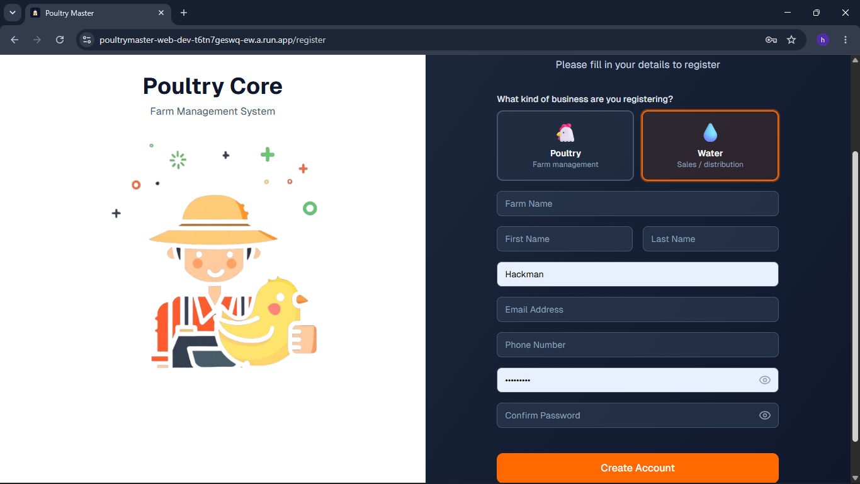
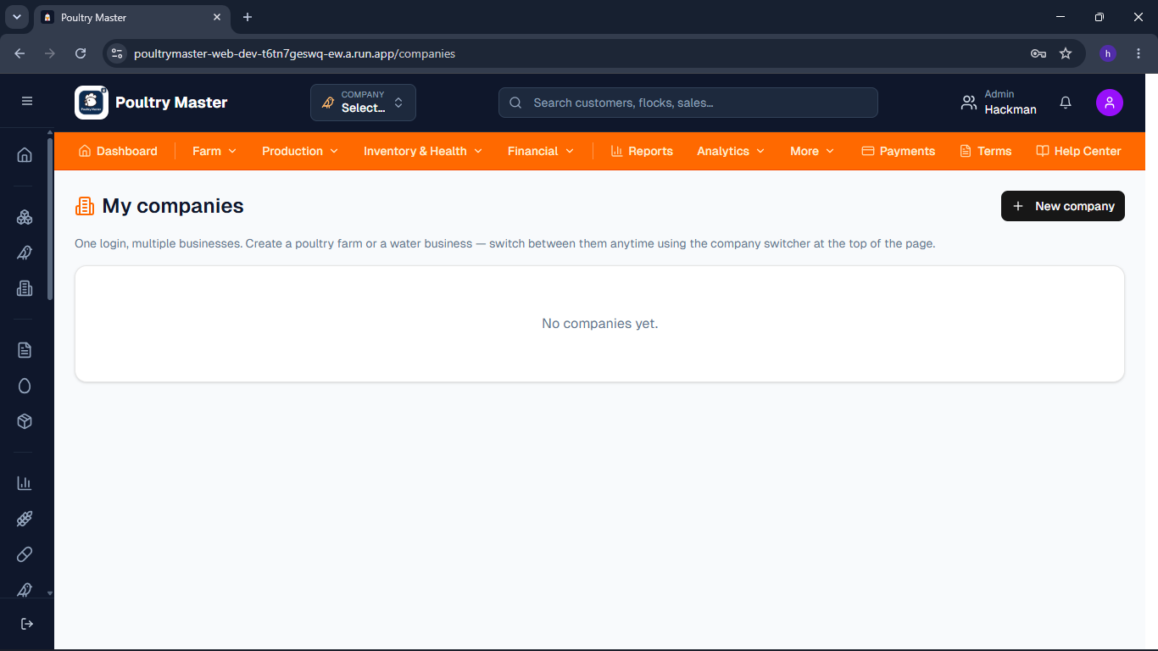
2. The "Forgot Password" feature is still not functioning correctly.
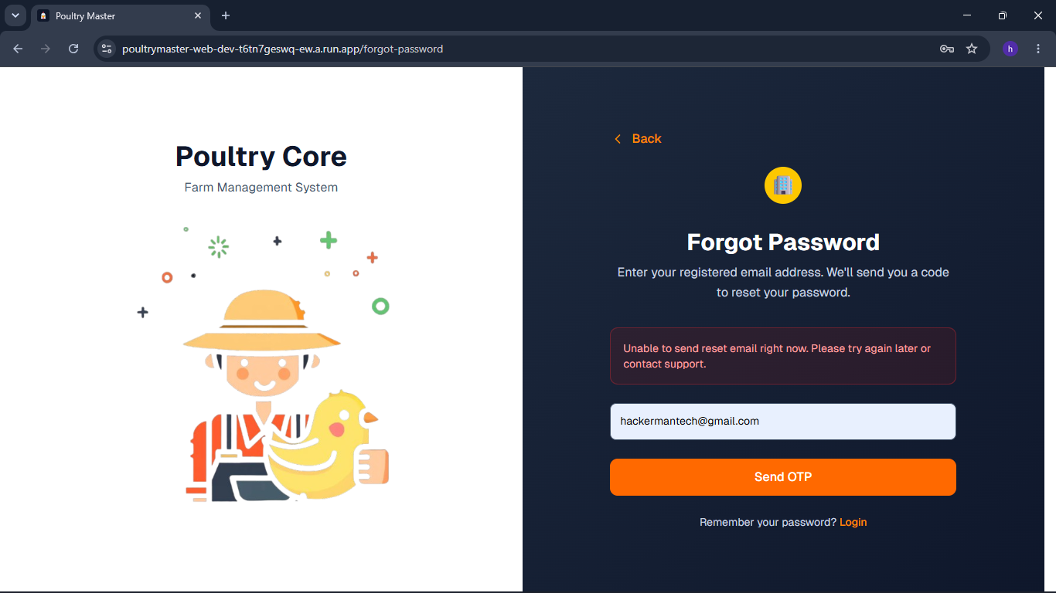

3. The highlighted tap bar is cut off.
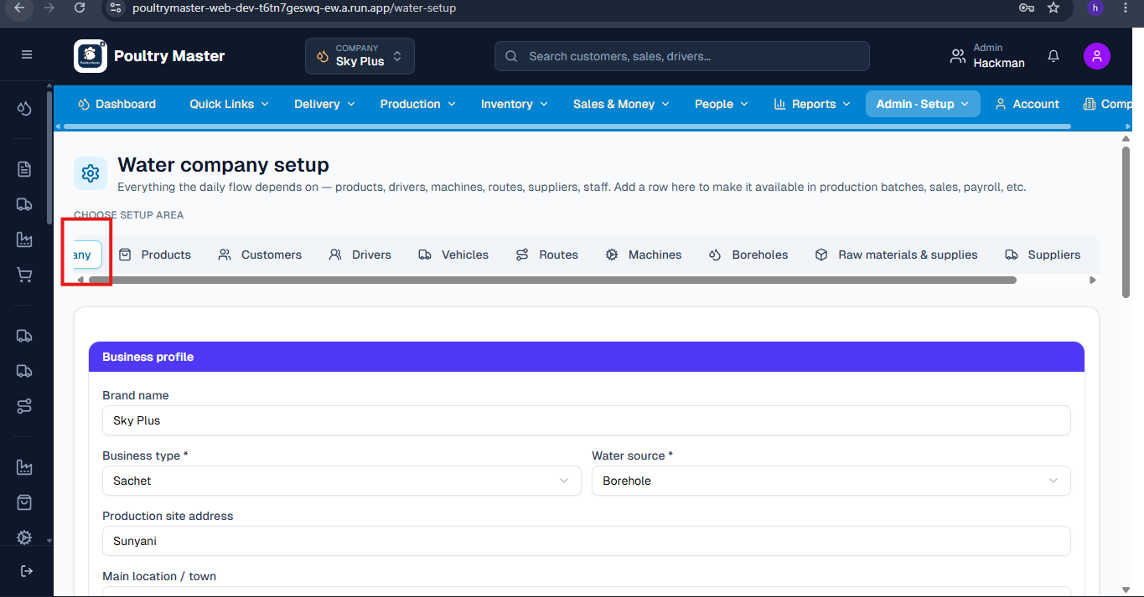

4 When setting up a new machine in the maintenance section, you can still select a last maintenance date that is in the future. For example, if today is 5th June, you can set the last maintenance date to 30th June.

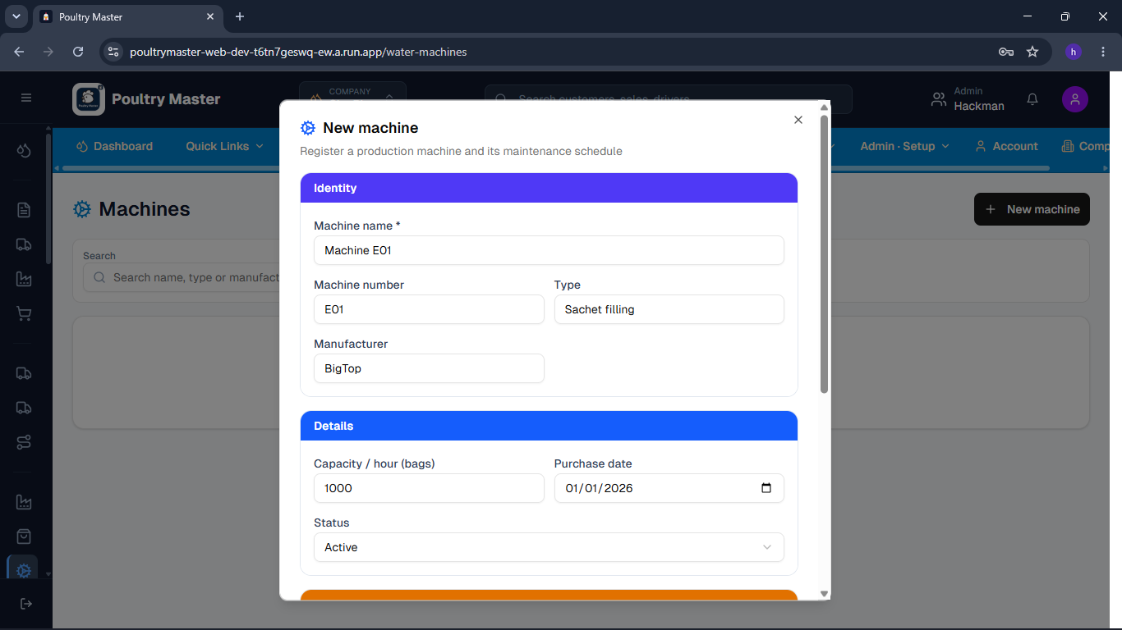
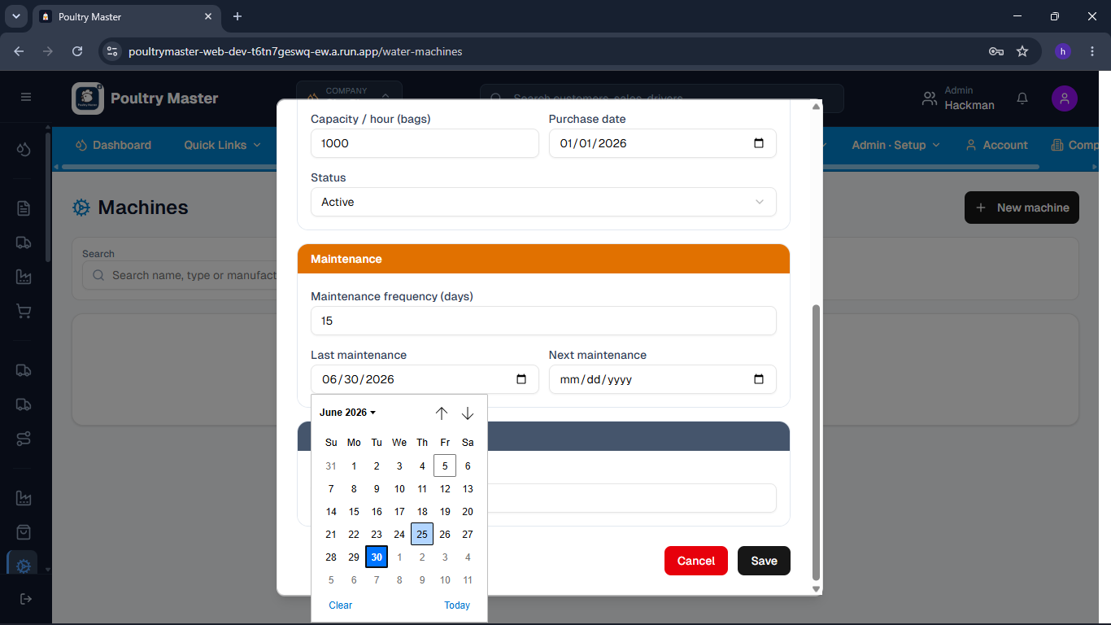
5. Part payment was made during the purchase of raw materials and supplies, but the balance shows as Gh0.00, which should reflect the amount we still need to pay.
